UNITED STATES

SECURITIES AND EXCHANGE COMMISSION

Washington, D.C. 20549

FORM 6-K

REPORT OF FOREIGN PRIVATE ISSUER PURSUANT TO RULE 13a-16 OR 15d-16 UNDER THE SECURITIES EXCHANGE ACT OF 1934

For the month of March 2026

Commission File Number: 001-41421

Alvotech

(Translation of registrant's name into English)

9, Rue de Bitbourg,

L-1273 Luxembourg,
Grand Duchy of Luxembourg

(Address of principal executive office)

Indicate by check mark whether the registrant files or will file annual reports under cover of Form 20-F or Form 40-F. Form 20-F [ X ] Form 40-F [ ]

Incorporation by Reference

This Report on Form 6-K (this “Report”) of Alvotech (the “Company”) excluding Exhibits 99.1, 99.2 and 99.3 attached hereto, shall be deemed to be incorporated by reference into the Company’s registration statements on Forms F-3 (File Nos. 333-266136, 333-273262, 333-275111 and 333-281684), the Company’s registration statement on Form F-3ASR (File No. 333-289006), and the Company’s registration statement on Form S-8 (File No. 333-266881) and to be a part thereof from the date on which this Report is filed, to the extent not superseded by documents or reports subsequently filed or furnished.

Exhibits 99.1, 99.2 and 99.3 to this Report are being furnished and shall not be deemed “filed” for purposes of Section 18 of the Securities Exchange Act of 1934 (the “Exchange Act”) or otherwise subject to the liabilities of that section, nor shall it be deemed incorporated by reference in any filing under the Securities Act of 1933 or the Exchange Act.

Press Release

On March 18, 2026, Alvotech issued a Press Release announcing the Financial Results and Business Update for Q4 2025 and the full year. A copy of the Press Release is furnished herewith as Exhibit 99.1.

Earnings Report and Presentation

On March 18, 2026, Alvotech made public a more detailed earnings report with Financial Results and Business Update for Q4 2025 and the full year. A copy is furnished herewith as Exhibit 99.2. The Company also made public its Earnings Call Presentation. A copy is furnished herewith as Exhibit 99.3.

EXHIBIT INDEX

Exhibit Number |  |  |  | Description
99.1 |  |  |  | Press Release dated March 18, 2026
99.2 |  |  |  | Earnings Report
99.3 |  |  | Earnings Call Presentation

SIGNATURES

Pursuant to the requirements of the Securities Exchange Act of 1934, the registrant has duly caused this report to be signed on its behalf by the undersigned, thereunto duly authorized.

 |  | Alvotech
 |  | (Registrant)
Date: March 19, 2026 | /s/ Tanya Zharov
 |  | Tanya Zharov
 | General Counsel

EXHIBIT 99.1

Alvotech Q4 2025 and Full Year 2025 Financial Results

A supplemental long‑form earnings release providing additional operational details and business update for Q4 2025 and the full year is available at: https://investors.alvotech.com/earnings-calendar The supplemental document is provided solely for reference and is not part of this SEC Form 6‑K. The Form 6‑K should not be read together with, or construed as referring to, the supplemental long‑form release.

Financial Highlights

Q4 2025 Highlights

Total revenues¹ were $173 million, up 13% Year-on-Year (YoY)
Adjusted EBITDA¹ was $69 million with Gross Margin at 66%
AVT05 was approved as a biosimilar to Simponi® in the UK and European Economic Area (EEA)

AVT03 was approved as a biosimilar to Prolia® and Xgeva® in the EEA

The EMA accepted for review a marketing application for AVT23, referencing Xolair®

After the end of the quarter, Alvotech entered into supply and commercialization agreements with Sandoz, covering multiple biosimilars candidates in Canada, Australia and New Zealand

FY 2025 Highlights

Total revenues¹ were $593 million, up 21% YoY
Adjusted EBITDA¹ was $137 million, up 27% YoY, with Gross Margin at 61% The cash balance on December 31, 2025, was $172 million

Second biosimilar in the US, Selarsdi™ referencing Stelara® launched by commercial partner Teva Three new biosimilars were approved in multiple markets, including the UK, EEA and Japan Alvotech acquired Xbrane’s R&D organization in Sweden and Ivers-Lee Group in Switzerland The company listed its shares on Nasdaq Stockholm and raised new equity
Linda Jonsdottir was appointed Chief Financial Officer, Dr. Balaji V. Prasad was appointed Chief Strategy Officer, while Joseph McClellan transitioned into the role of Chief Operating Officer and Anthony Maffia into the role of Chief Regulatory and Quality Officer

Comments by Chairman of the Board and Outgoing CEO, Róbert Wessman:

“Last year we continued to expand our dedicated end-to-end biosimilars platform, advancing our pipeline with the launches of three newly approved biosimilars, expanding our R&D operation and adding a centralized assembly and packaging unit through acquisitions, while also strengthening our global network through new commercial partnerships.

“We now have five approved and on-market biosimilars supported by our global partners which provide Alvotech with commercial reach into 90 countries worldwide. We have an industry leading pipeline of 30 biosimilars in development and continue adding to it at an accelerated pace.

“During the year we further strengthened our financial position, raising close to $300 million from capital markets to support continued investment in our development programs and manufacturing platform. We broadened our investor base through the listing of shares on Nasdaq Stockholm, providing better access to Nordic and European investors.

“At the same time, we addressed the regulatory observations following the FDA inspection of our Reykjavik manufacturing facility and we implemented a comprehensive improvement program. Based on the progress made so far, we expect to resubmit the affected applications to the FDA during the second quarter of 2026. We have addressed regulatory observations before, and we know how to resolve them. Our focus has been on strengthening the operational platform so that we can continue to scale the business globally.

“We have strengthened the leadership team, with Lisa Graver’s appointment as Chief Executive Officer, and all the key management of the company is now located onsite in Iceland. Lisa and I have worked together for over twenty years, and she is ideally positioned to lead the company through this next stage. She knows the company very well, having been a board member since 2022, which gives her a deep understanding of our strategy, our platform and our global partnerships.

“As Executive Chairman of the Board I will continue to be actively engaged in the business, and I am looking forward working closely with Lisa and the leadership team as we continue building Alvotech into a leading biosimilars company.”

Outlook for 2026

Management reaffirms its outlook for 2026. With continued focus on robust cash flow and margin expansion by delivering solid sales growth and driving operational efficiencies across the company, management anticipates total revenues in the range of $650-700 million in 2026, reflecting continued double-digit sales growth. Adjusted EBITDA is expected to increase to $180-220 million, supported by higher volumes of commercialized products and launches of newly approved products in Europe, the UK and Japan.

Alvotech anticipates receiving U.S. approval by late 2026 for four Biologics License Applications from the U.S. Food and Drug Administration, with minimal impact on the topline. The lower end of the revenue range assumes no revenues from new launches into the U.S. market in 2026.

Invitation to Q4 2025 and Full Year 2025 management presentation:

Join us to listen to the live audio webcast at 8:00 AM EST (12:00 GMT, 13:00 CET) on Thursday, March 19, 2026.

The audio webcast will be accessible via the following link:

https://edge.media-server.com/mmc/p/u2p8ged8/

To participate via telephone in the Q&A session, please register using this link to obtain your PIN:

https://register-conf.media-server.com/register/BI1c565f9bbee94c928c676ea73f178077

Presentation slides for the webcast and other materials are available on the company’s website:

https://investors.alvotech.com/earnings-calendar

For further information, please contact:

Media – alvotech.media@alvotech.com

Benedikt Stefansson
Sarah MacLeod

Investors - alvotech.ir@alvotech.com

Dr. Balaji V Prasad (US)
Patrik Ling (SE)

Benedikt Stefansson (IS)

The information was submitted for publication through the agency of the contact persons.

Financial calendar:

Annual or interim results will be released on the dates specified below, after the close of U.S. markets. An earnings call is held on the following day, after release of the results. Please note that all dates are subject to change.

Quarter | Date of release | Date of earnings call
Q1 2026 | May 6, 2026 | May 7, 2026
Q2 2026 | August 19, 2026 | August 20, 2026
Q3 2026 | November 11, 2026 | November 12, 2026
Q4 2026 | March 10, 2027 | March 11, 2027

About Alvotech

Alvotech is a biotechnology company, founded by Robert Wessman, focused solely on the development and manufacture of biosimilar medicines for patients worldwide. Alvotech seeks to be a global leader in the biosimilar space by delivering high-quality, cost-effective products and services, enabled by a fully integrated approach and broad in-house capabilities. Five biosimilars are already approved and marketed in multiple global markets, including biosimilars to Humira® (adalimumab), Stelara® (ustekinumab), Simponi® (golimumab), Eylea® (aflibercept) and Prolia®/Xgeva® (denosumab). The current development pipeline includes nine disclosed biosimilar candidates aimed at treating autoimmune disorders, eye disorders, osteoporosis, respiratory disease, and cancer. Alvotech has formed a network of strategic commercial partnerships to provide global reach and leverage local expertise in markets that include the United States, Europe, Japan, China, and other Asian countries and large parts of South America, Africa and the Middle East. For more information, please visit https://www.alvotech.com. None of the information on the Alvotech website shall be deemed part of this press release.

For more information, please visit our investor portal, and our website or follow us on social media on LinkedIn, Facebook, Instagram, and YouTube.

Forward Looking Statements

Certain statements in this communication may be considered “forward-looking statements” within the meaning of the Private Securities Litigation Reform Act of 1995, as amended. Forward-looking statements include, for example, Alvotech’s expectations regarding competitive advantages, business prospects and opportunities including pipeline product development, future plans and intentions, regulatory submissions, review and interactions, the potential approval and commercial launch of its product candidates, the timing of regulatory approval, market launches and financial projections. Such forward-looking statements are subject to risks, uncertainties, and other factors which could cause actual results to differ materially from those expressed or implied by such forward-looking statements. These forward-looking statements are based upon estimates and assumptions that, while considered reasonable by Alvotech and its management, are inherently uncertain and are inherently subject to risks, variability, and contingencies, many of which are beyond Alvotech’s control. Factors that may cause actual results to differ materially from current expectations include, but are not limited to factors set forth in the sections entitled “Risk Factors” and “Cautionary Note Regarding Forward-Looking Statements” in documents that Alvotech may from time-to-time file or furnish with the SEC. There may be additional risks that Alvotech does not presently know or that Alvotech currently believes are immaterial that could also cause actual results to differ from those contained in the forward-looking statements. These forward-looking statements are provided for illustrative purposes only and are not intended to serve as, and must not be relied on by an investor as, a guarantee, assurance, prediction or definitive statement of a fact or probability. Alvotech does not undertake any duty to update these forward-looking statements or to inform the recipient of any matters of which any of them becomes aware of which may affect any matter referred to in this communication. Alvotech disclaims any and all liability for any loss or damage (whether foreseeable or not) suffered or

incurred by any person or entity as a result of anything contained or omitted from this communication and such liability is expressly disclaimed.

Non IFRS Financial Measures

This Presentation may include projections of certain financial measures not presented in accordance with International Financial Reporting Standards (“IFRS”) including, but not limited to, Adjusted Revenues, EBITDA and certain ratios and other metrics derived therefrom. These non-IFRS financial measures are not measures of financial performance in accordance with IFRS and may exclude items that are significant in understanding and assessing the Company’s financial results. Therefore, these measures should not be considered in isolation or as an alternative to net income, cash flows from operations or other measures of profitability, liquidity or performance under IFRS. You should be aware that the Company’s presentation of these measures may not be comparable to similarly-titled measures used by other companies. The Company believes these non-IFRS measures of financial results provide useful information to management and investors regarding certain financial and business trends relating to the Company’s financial condition and results of operations. The Company believes that the use of these non-IFRS financial measures provide an additional tool for investors to use in evaluating ongoing operating results and trends and in comparing the Company’s financial measures with other similar companies, many of which present similar non-IFRS financial measures to investors. These non-IFRS financial measures are subject to inherent limitations as they reflect the exercise of judgments by management about which expense and income are excluded or included in determining these non-IFRS financial measures. Due to the high variability and difficulty in making accurate forecasts and projections of some of the information excluded from these projected measures, together with some of the excluded information not being ascertainable or accessible, the Company is unable to quantify certain amounts that would be required to be included in the most directly comparable IFRS financial measures without unreasonable effort. Consequently, no disclosure of estimated comparable IFRS measures is included and no reconciliation of the forward-looking non-IFRS financial measures is included. For the same reasons, the Company is unable to address the probable significance of the unavailable information, which could be material to future results.

- Figures are adjusted to exclude items that are not indicative of our ongoing operating performance. Please see the disclaimer on ‘Non IFRS Financial Measures’ at the end of this press release. As a foreign private issuer, Alvotech is not required to, and does not, prepare or file quarterly financial statements under IFRS or with the SEC. The financial information included in this Form 6-K reflects management’s current estimates and is presented for the purpose of providing an interim business update.

Exhibit 99.2
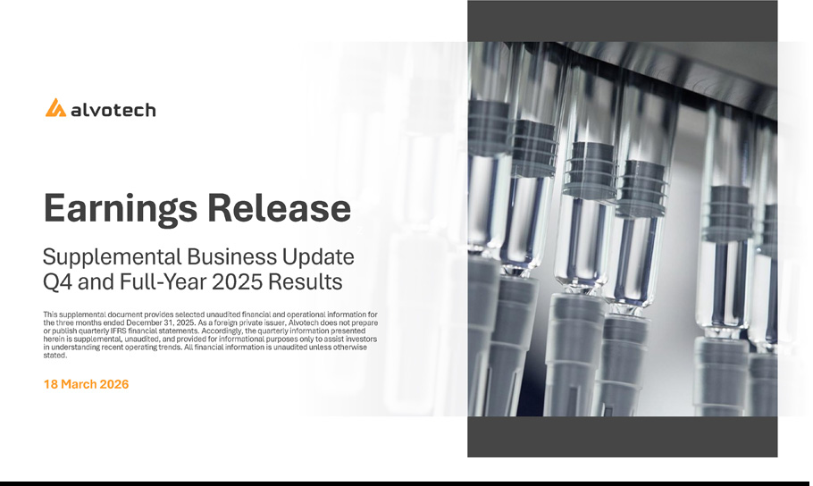

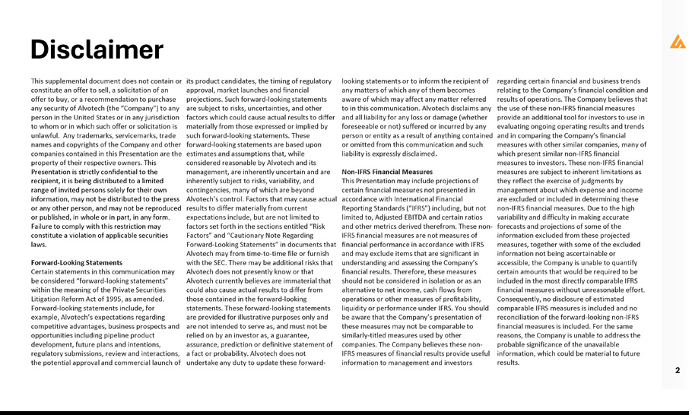

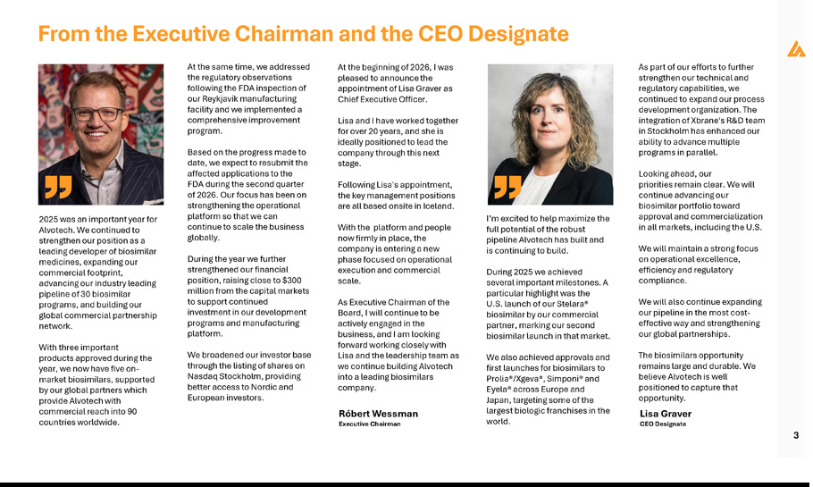

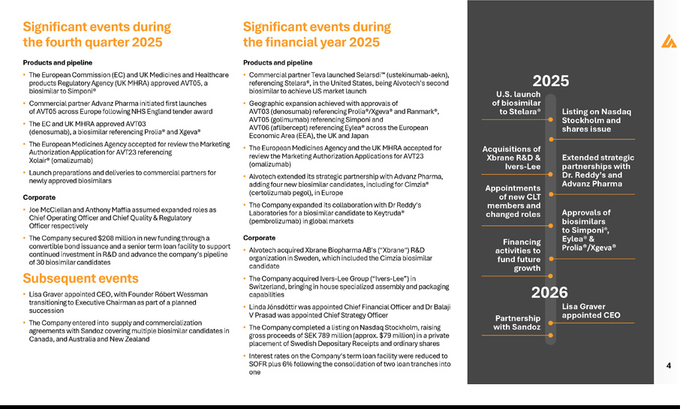

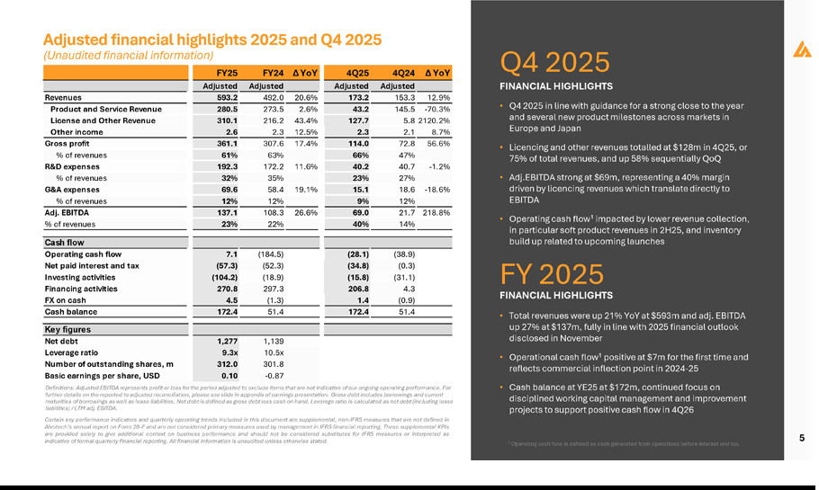

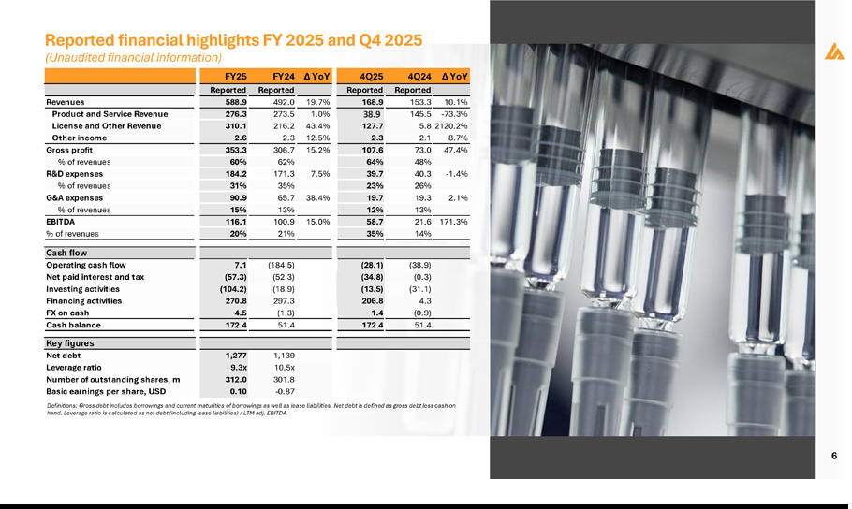

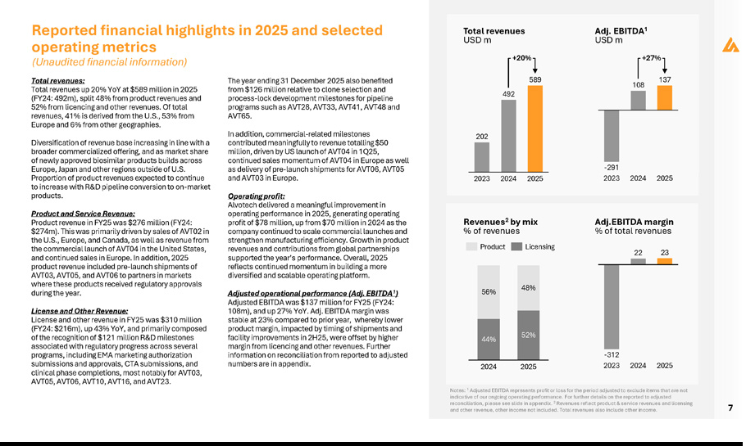

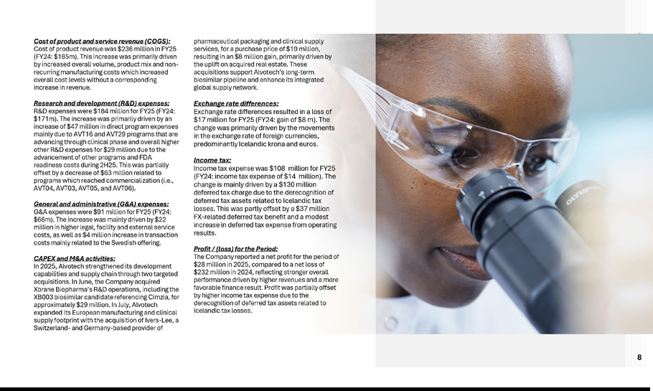

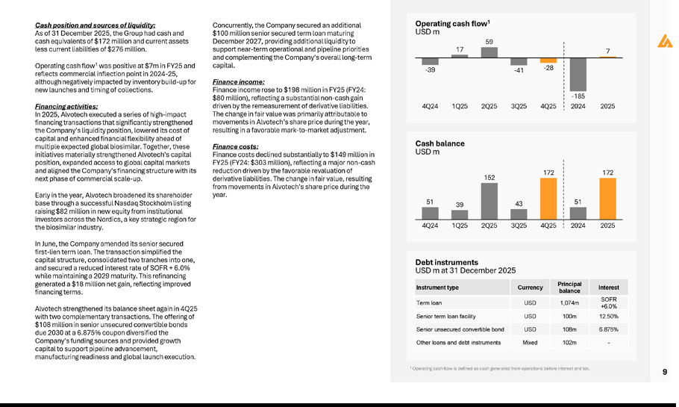

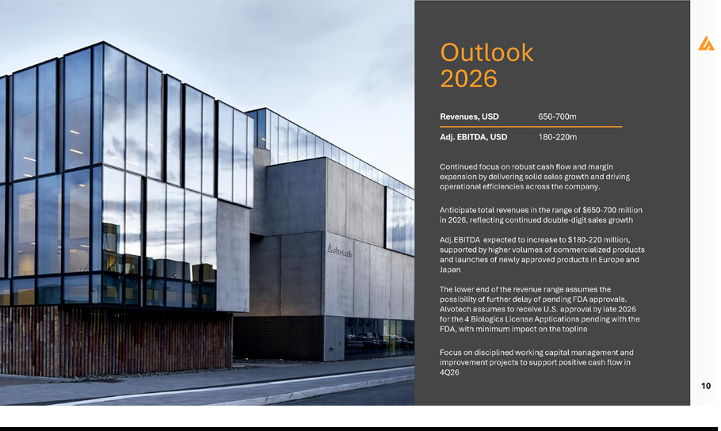

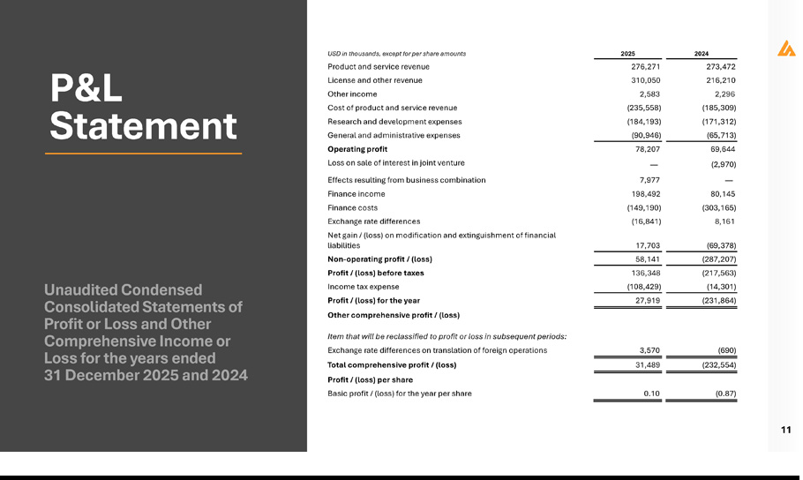

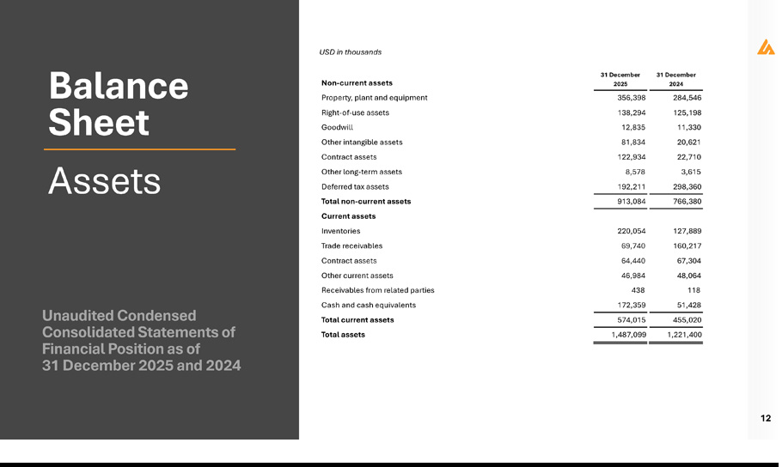

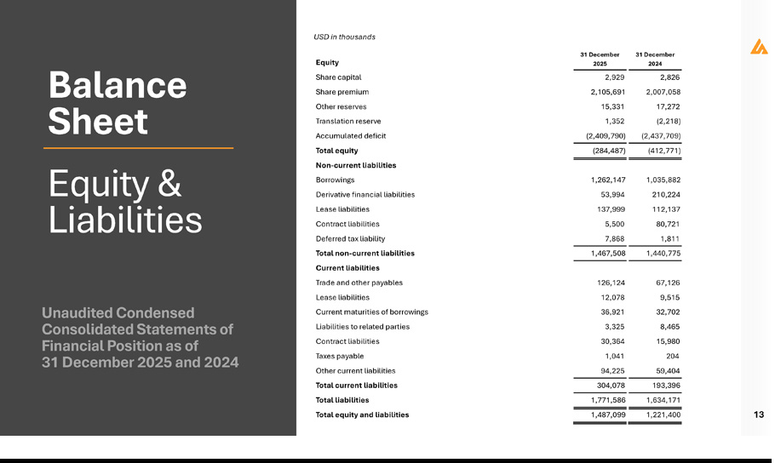

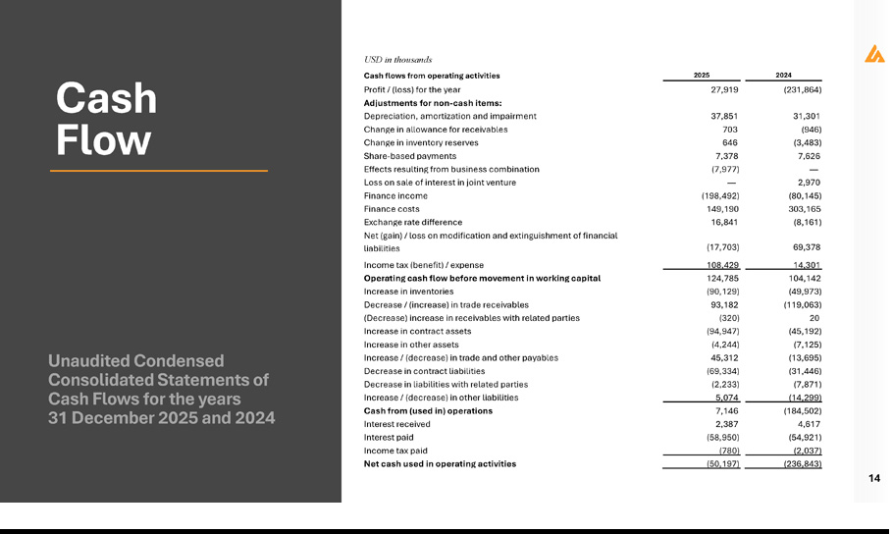

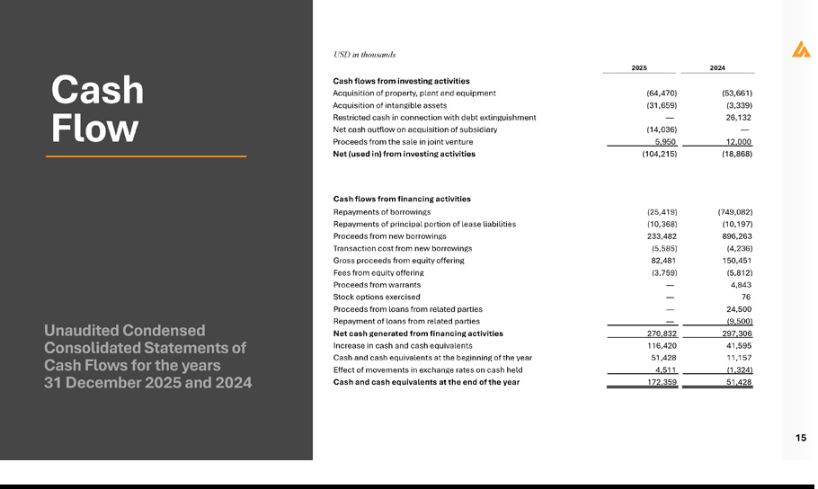

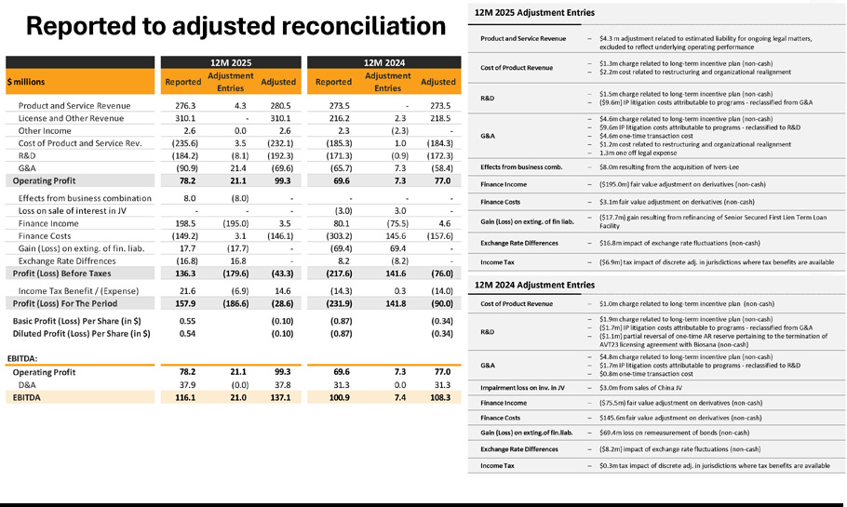

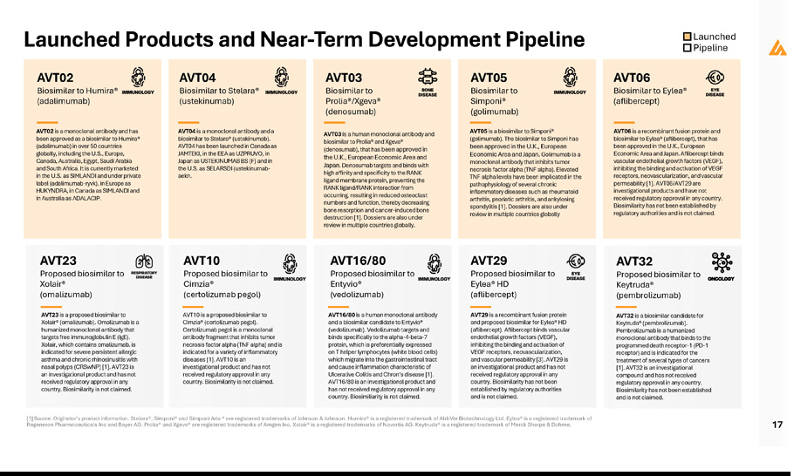

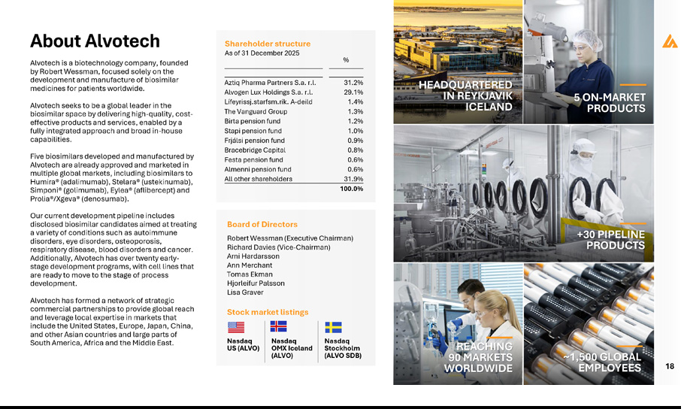

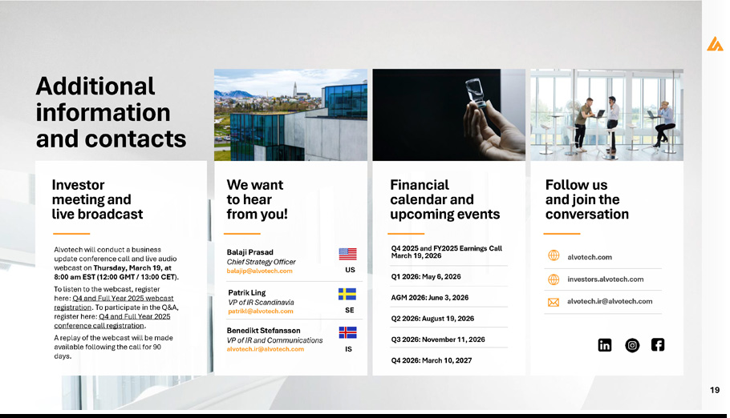

Exhibit 99.3


